

Software Requirements Specification

CS684 Projects

Tennis Ball Collector Robot

Group No: 17

Raj Deepak P 10305081
Vishnu Kanth T 10305020
Anup Naik 10305915

Table of Contents

Introduction 3
Definitions, Acronyms and Abbreviations 3
References 3
Overall Description 3
Details 5
Functionality 5
Supportability 5
Design Constraints 6
Interfaces 6
User Interfaces 6
Hardware Interfaces 6
Software Interfaces 6
Communications Interfaces 6

1. Introduction
This project aims to use the Firebird V as a tennis ball collector. It will collect the balls which are scattered on the ground and place it at a specified location.

1.1. Definitions, Acronyms and Abbreviations

Firebird V: A robot indigenously designed at ERTS laboratory, IIT Bombay.
ATMEGA2560: The microcontroller used by Firebird V robot
AVR GCC: The platform-specific compiler which compiles C code to run on various AVR microcontrollers developed by Atmel
WinAVR: Open-source software which uses AVR GCC compiler
AVR Studio: Open-source software which uses AVR GCC compiler
Matlab: Matlab (matrix laboratory) is a numerical computing environment and fourth generation fourth-generation programming language developed by Math Works

1.2. References
    - FIRE BIRD V ATMEGA2560 Robotic Research Platform Hardware Manual. IIT Bombay & NEX Robotics Pvt. Ltd.
    - FIRE BIRD V ATMEGA2560 Robotic Research Platform Software Manual. IIT Bombay & NEX Robotics Pvt. Ltd.
    - ATmega640/1280/1281/2560/2561 Datasheet provided by ATMEL.

2. Overall Description
The project involves programming the robot to collect balls scattered in a court and place it at a specified location. When the robot is switched on , the robot scans for balls (of a specified colour) and if a ball is detected, it collects it and places it at a specified location and again scans for more balls. This will continue till all balls are collected. The location at which the balls are to be collected is identified by either a specific colour box or a beacon. The balls are collected using a gripper enhancement attached to the robot.

2.1. Product Perspective
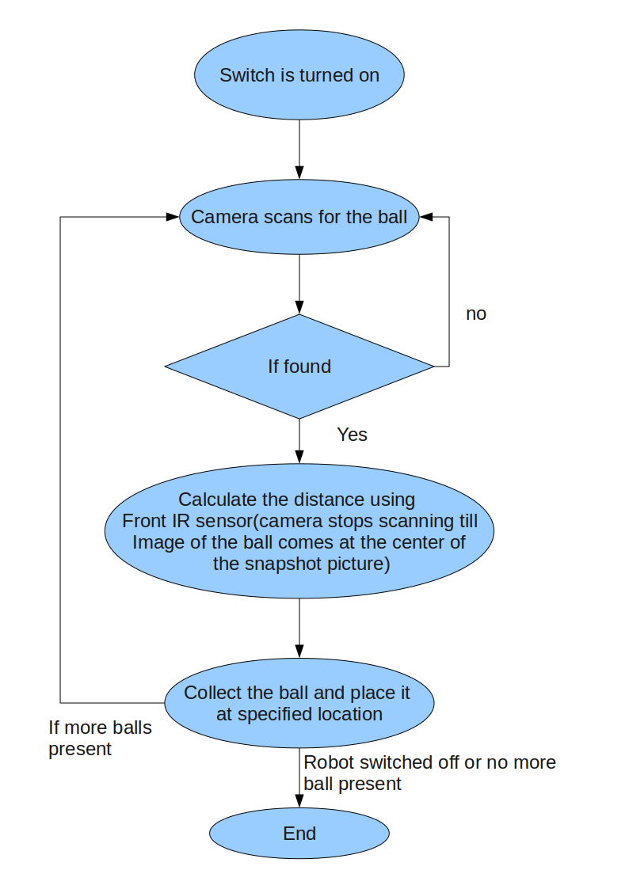

2.1.1. Product Functions
Function of the robot is to collect the balls scattered in a field. So some of the sub-functions are:
- Take snapshot of the environment.
- Process the image to find whether the ball is present in the image (robot rotates and take snapshot till image of the ball appears at the middle of the snapshot image).
- Calculate the distance of the ball from the current position using front IR sensor since now the ball is at the centre of the image and hence in front of the robot.
- Go near the ball and collect it using the grabber and place it at a specified location.

2.1.2. User Characteristics
This is an autonomous robot and hence no much user intervention is required.
2.1.3. Constraints
- Also distance of the ball from the current position need to be identified.
- Identifying the ball using the camera (camera is at a different angle and height with respect to the robot).So this thing should be taken care of.
2.1.4. Assumptions and Dependencies
- The ATMEGA2560 can execute HEX files.
2.1.5. Requirements Subsets
- Firebird V gripper robot
- Mounted Camera
- Zigbee module

3. Details

3.1. Functionality
- The camera on the robot should be able to collect snapshots and send it to the computer for processing.
- On finding the ball the robot should be able to grab the ball using a gripper.

3.2. Supportability

- Code will be written such that it will be extendable in the future.
- All the platform dependent code will be written in a separate file so that if any upgrading needs to be done, then only that file needs to be changed and not the entire logic.
- So project will be extendable.

3.3. Design Constraints
- Identifying the ball using the camera.(camera is at a different angle and height with respect to the robot).So this thing should be taken care of.
- Also distance of the ball from the current position need to be identified.

3.4. Interfaces

3.4.1. User Interfaces
As such no user intervention is required for the working except to turn on/off the switch. All the logic for automatic working is embedded in the microcontroller memory.

3.4.2. Hardware Interfaces

ATMega2560: Master Microcontroller in Firebird V
ATMega8: Slave Microcontroller in Firebird V
RAM and Flash Memory: Already available as a part of the microcontroller.
Power Supply: External 7.4V, 1800mAh Lithium Polymer Battery.
Gripper attachment: Used to grab the balls which are scattered on the ground.
Camera: Camera is used to take snapshot of the environment to detect the balls.

3.4.3. Software Interfaces

Compiler: AVR GCC (Specific to Atmel AVR processors)
Development Tools and IDEs: WinAVR, AVR Studio 4.0., Matlab (for image processing).
Programming Languages: C

3.4.4. Communications Interfaces
Zigbee communication is required for the robot to communicate to the computer for the purpose of Image processing. The robot will take snapshots and send it to the computer where it will process the image to find whether the ball is present or not.

